Goal 2: Cells Introduction Name_____________________________Pd____

Learning Target(s)—I can... How are cells classified?
- Describe the Cell Theory.
- Differentiate between prokaryotes and eukaryotes.

Cell Introduction Notes
- Intro to The Cell
- _________: The ____________ unit of _________ and the ___________________ unit of _______________ that can carry out all of the processes of ____________.

- Discovery of the Cell
Match each scientist to his discovery from the video

_____ Robert Hooke a. Discovered that animals were made up of cells

_____Anton Van Leeuwen Hoek b. Discovered that plants were made up of cells

_____Matthias Schleiden c. Discovered the cellular composition of cork and introduced
the word cell to science.
_____Theodor Schwann d. Stated that all living things come from other living things.

_____Rudolph Virchow e. “Animacules” were discovered; discovered bacteria from a
sample of saliva from his mouth

- Made possible by the development of the __________________________.

- Cell Theory: The contributions of these scientists created what we call the cell theory:

- Prokaryotes vs. Eukaryotes
Characteristics | Prokaryotes | Eukaryotes
Unicellular or multicellular?
Nucleus?
Membrane-bound organelles?
Complexity
Specialized functions?
Genetic Material
Types of Cells

- Cell Types: Complete the comparison chart for the different types of cells.
Cell Type | Description | Picture
Bacterial Cells  [ Prokaryote / Eukaryote ] | See above
Animal Cells
[ Prokaryote / Eukaryote ]

Plant Cells
[ Prokaryote / Eukaryote ]

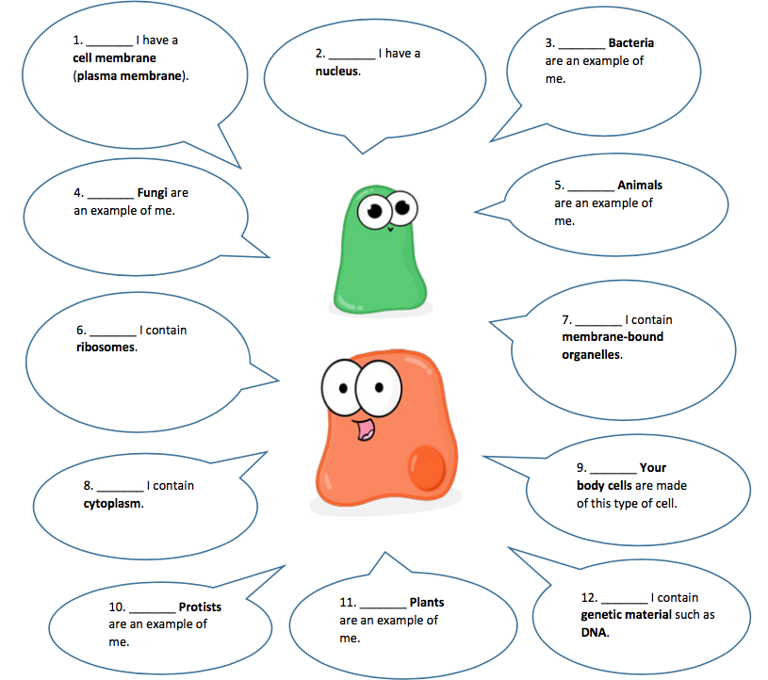
Amoeba Sisters: Cells Intro https://youtu.be/8IlzKri08kk
oeba Sisters: Prokaryotic vs. Eukaryotic Cells WS page 1 goes here!

Prokaryotes-Eukaryote Comparison: Compare and contrast Prokaryotes and Eukaryotes in the space below. It must take up the full space and include color. Include the following terms:
Animal cells | Archaea | Bacteria | Cell membrane
Cell wall | Cytoplasm | DNA | Eukaryote/eukaryotic
Fungus cells | Genetic material | Membrane-bound organelles | Multicellular
Nucleus | Plant ells | Prokaryote/prokaryotic | Protist cells
Ribosomes | Unicellular

Check Your Understanding: Use your notes to answer the following questions in complete sentences.

- What are the three parts of the cell theory?

- Choose 3 scientists. How did each one contribute to the cell theory?

- Compare and contrast prokaryotes and eukaryotes.

- Compare and contrast plant and animal cells.

